Use-Case Realization Report (Design)
Update Survey

Issue <1.0>
Revision History
Date | Issue | Description | Author
<25/Oct/09> | <1.0> | <Initial version> | <Thomas Yap>

Table of Contents
1. Brief Description 4
2. Flow of Events 4
2.1 Standard Flow 4
2.1.1 Update Survey 4
3. Interaction Diagrams 5
3.1 Collaboration Diagram for Update Survey 5
3.2 Sequence Diagram for Update Survey 6
4. Participating Objects 7
5. Class Diagrams 7
5.1 Class Diagram for Update Survey 7
6. Derived Requirements 7

Use-Case Realization Report
Update Survey

Brief Description
This use case enables the controller to update survey from Survey Pool. It involves displaying the menu and form for selecting the list to update the record.

Flow of Events
The standard flow of events for this use case and any exceptions are described in the following subsections. The events are described in terms of Actors and Design Objects.

Standard Flow
This use case covers the Survey Maintenance - Update Survey. The standard flows of these events are described below.

Update Survey
The running of the application is shown in section 3.1. The flow of event is as follow:

- When the application start, the first operation to be performed is the startup operation of the main controller. This operation will create all the control objects and the entity objects necessary for operation Update Survey:
  - The control object created is: SurveyBL Controller
  - The entity objects create are: survey_master, survey_qn_master and survey_qn_option.

- The main controller will start the main function menu:
  - To start Update Survey, operation page_load() is activated by SurveyBL Controller to display a Survey form.
  - PopulateSurveyList() will retrieve a title list of Survey for Portal Admin to select to be displayed on form Survey.
  - After that, SurveyQuestion interface is activated by page_load(). PopulateObjectList() will displayed the list of survey question. Portal admin can then select the survey question that to be modified.
  - SurveyQuestionMaintenance interface will be activated by page_load() and survey question details will be populated by populatequestionoption().
  - Portal Admin input the change and click on Update button to confirm.
  - Upon confirmation, the record will then be updated to table using operation UpdateSurvey(), UpdateQuestion() and InsertQuestionOption() to entity objects survey_master, survey_qn_master and survey_qn_option.
  - The request can be cancelled by clicking cancel button and no data will be altered. A confirmation message will be displayed by form Survey interface.

- Step 2 will be repeated until all deletions are completion. Then controller will terminate the application by issuing operation close.

Interaction Diagrams

Collaboration Diagram for Update Survey
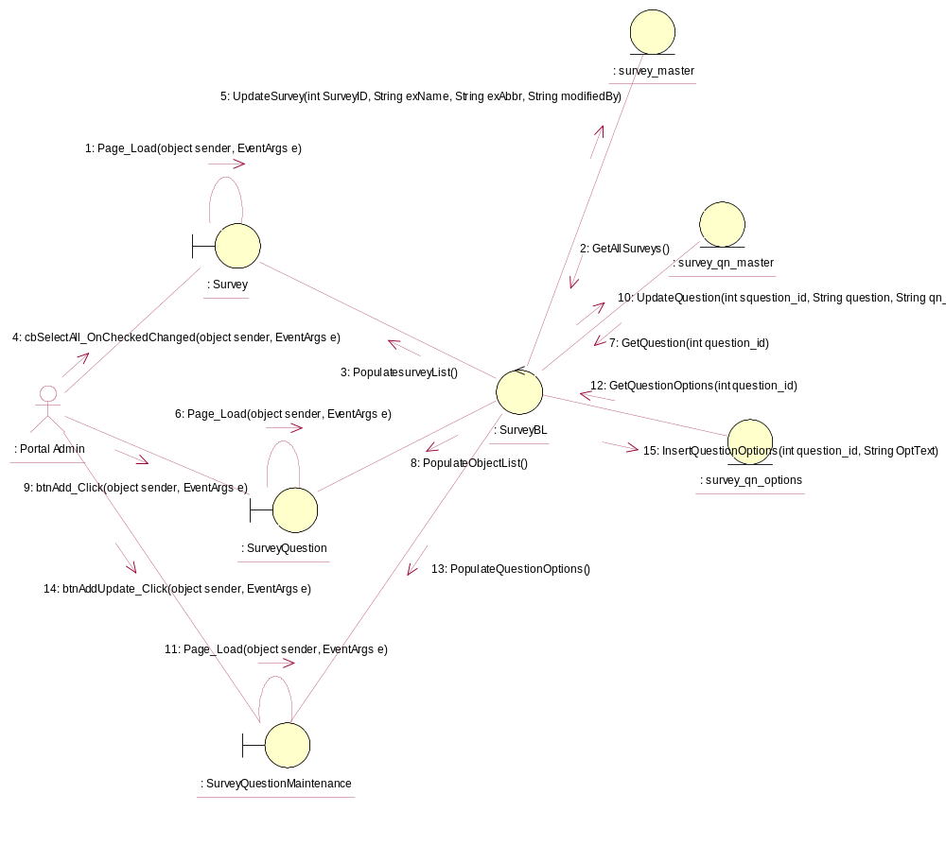

Sequence Diagram for Update Survey
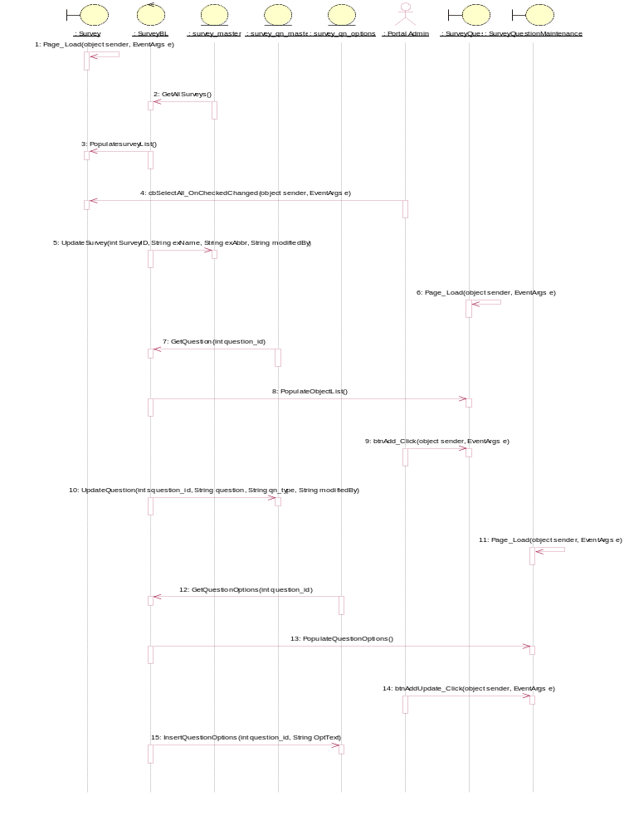

Participating Objects
: Portal Admin

: Survey

: survey_master

: survey_qn_master

: survey_qn_options

: SurveyBL

: SurveyQuestion

: SurveyQuestionMaintenance

Class Diagrams

Class Diagram for Update Survey
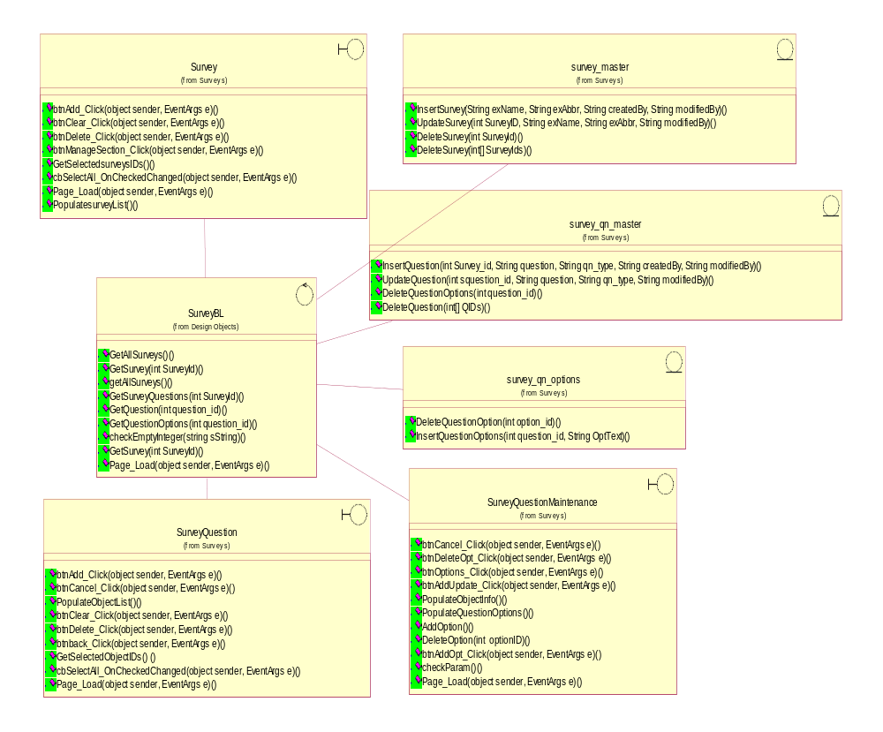

Derived Requirements
[enter the derived requirements here]

